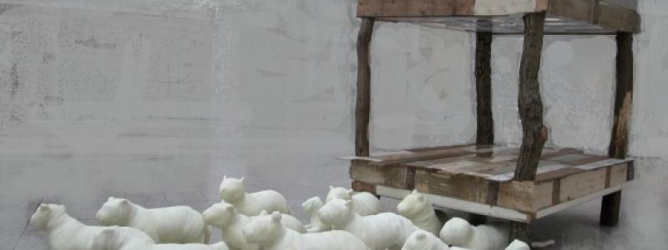
Museum information

Kunstwerk Splinter in Den Haag - Ciska de Hartogh
From Friday, January 8, 2016 to Thursday, March 31, 2016
From Jan 8, 2016 to Mar 31, 2016
Humanity House, The Hague
For more information about the exhibition Kunstwerk Splinter in Den Haag - Ciska de Hartogh, please visit the website of Humanity House.

